2018-2019

North Dakota Department of human services

Children’s prevention and early intervention behavioral health pilot project

Invitation to Apply (ITA)

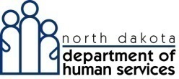
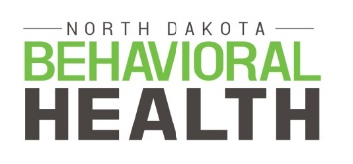
www.behavioralhealth.nd.gov

Table of Contents
Funding Opportunity Description 2
Eligible Applicants 2
Background 2
Goal of the project 2
Contract Dates 2
Expectations/Scope of Work 3
Funding Availability and Distribution 3
Application and Submission Information 3
Deadline for ITA Submission 3
Review Process 3
Contact Information 3
Invitation to Apply Form 4
Eligibility checklist 4
Narrative proposal 5

Funding Opportunity Description

Eligible Applicants
Applications will be accepted from North Dakota public or private elementary or middle schools which are able to demonstrate the following criteria:
- Leadership support for innovative solutions regarding behavioral health.
- School culture supportive of behavioral health, illustrated by documentation of efforts taken to implement strategies supporting behavioral health of all children.
- Sustained implementation of prevention and early intervention efforts.
- Successful implementation of the Multi-Tier Systems of Support (MTSS).
- Readiness to implement strategies within 30 days of award.
- Ability to develop and implement a sustainability plan.

Background
The ND 65th Legislative Assembly passed House Bill 1040 appropriating $150,000 to the Department of Human Services for the purpose of establishing a children’s prevention and early intervention behavioral health services pilot project in the school system; including services to children suffering from the effects of behavioral health issues.
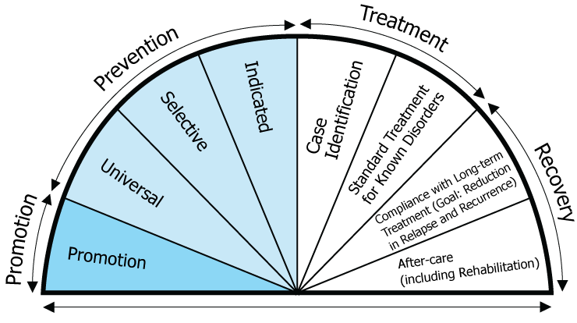
Through the passage of House Bill 1040, the North Dakota took a step towards supporting a comprehensive effort to coordinate behavioral health services in schools.
Behavioral health is a state of mental/emotional being and/or choices and actions that affect wellness. The North Dakota Behavioral Health System is grounded on the Institute of Medicine’s Continuum of Care model. The goal of this model is to ensure there is access to a full range of high quality services to meet the various needs of North Dakotans. The services available throughout this continuum should reflect current knowledge and technology and be grounded in evidence-based practice. Throughout all levels of the continuum, there should be a continuous promotion of healthy behaviors and lifestyles, a primary driver of health outcomes.

Goal of the project

The goal of the North Dakota School Pilot project is to develop a pilot which demonstrates improvement to children’s behavioral health in a school setting. Specifically developing an innovative systemic approach to addressing gaps in the school system related to prevention and early intervention of behavioral health conditions or related consequences.

Contract Dates
The contract will run from October 1, 2018 through June 30, 2019.

Expectations/Scope of Work
Vendor shall implement a project which addresses a gap(s) in the current school system and supports the behavioral health of children in the school setting.
Vendor shall ensure project aligns directly with the Behavioral Health Division values of person-centered; trauma-informed; and recovery-focused.
Vendor shall develop a sustainability plan by May 31, 2019.
Vendor shall develop tools and/or resources to transfer knowledge gained from pilot implementation to other schools by June 30, 2019.
Vendor shall participate in training and technical assistance.
Vendor shall report monthly to the State on progress.
Vendor must report initial progress/outcomes during the 2019 Legislative session as requested.
Vendor shall create a final evaluation report, demonstrating progress and outcomes of project and submit to the State by July 10, 2019.

Funding Availability and Distribution
Total available funding for this school pilot project is $150,000.

Application and Submission Information

Deadline for ITA Submission
Eligible applicants must submit a completed Invitation to Apply (ITA) form by midnight on September 24, 2018 to Kelli Ulberg at kulberg@nd.gov.

Review Process
Completed ITAs will be reviewed by the Department of Human Services - Behavioral Health Division. Allow up to one week following the application deadline for notice of award.

Contact Information
For questions, please contact Kelli Ulberg at kulberg@nd.gov or 701-328-8730.

Invitation to Apply Form

School Name
Address
Contact Person
E-mail
Phone

Identify which best describes your school:
☐Elementary School
☐Middle School
☐Grades K-9 School
☐Other: Click or tap here to enter text.

Eligibility checklist
☐ | Describe the school’s leadership support for innovative solutions regarding behavioral health.
☐ | Describe the school culture supportive of behavioral health, illustrated by documentation of efforts taken to implement strategies supporting behavioral health of all children.
☐ | Describe how the school has sustained implementation of prevention and early intervention efforts.
☐ | Describe the school’s successful implementation of the Multi-Tier Systems of Support (MTSS).
☐ | Briefly describe the school’s readiness to implement strategies within 30 days of award.
☐ | Briefly describe the school’s ability to develop and implement a sustainability plan.

Narrative proposal

Describe current needs and gaps in your school system that you would like to address in the school pilot project.

Describe your plan for the school pilot and how it will enhance the current behavioral health framework existing in your school system.

Describe how your school will ensure the school pilot project is sustainable for continued success and scalable to other schools.

Describe how your school will measure and demonstrate outcomes during the 66th legislative session.
**Please attach a cost proposal to the completed Invitation to Apply.

